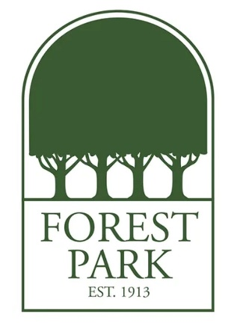
Mr. Rudy’s Favorite Things:
Birthday: July 20
Drink of Choice: Gatorade, Iced Coffee (low-fat or oat milk)
Place to Eat: Burge’s, Brave New, Capeo, Oyster Bar, Arthur’s
Initials: P.D.R.
Sweet Treat/Snack: Healthy Bars
Colors: Sky Blue
Favorite Place to Shop/Gift Cards: Ozark Outdoor Supply, Peter Millar, Baumans, Mr. Wicks
Hobbies & Interests: Sports, Gym, Gambling, Cards
Lunch Order: Burge’s (turkey sandwich, cheeseburger, tater tots or fries)
Taziki’s (Beef Gyro)

