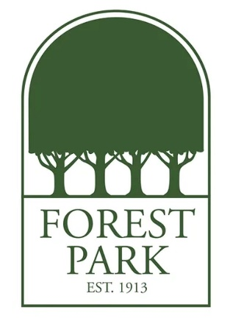
Ms. Turner's Favorite Things:
Birthday: August 25
Drink of Choice: Diet Coke with Lime
Place to Eat: Yaya's, Izzy's, Taziki's, Chick-fil-A
Initials: P.M.T.
Sweet Treat/Snack: Sweet: anything Chocolate / Snack: hummus, white cheddar popcorn, flavor blasted Goldfish crackers
Colors: Pink
Favorite Place to Shop/Gift Cards: Target, Amazon
Hobbies & Interests: Exercising, DIY projects, cooking
Lunch Order: Chick-fil-A: (eight count grilled nugget meal with a side of Pickles and Honey Roasted BBQ Sauce with a Coke Zero)

