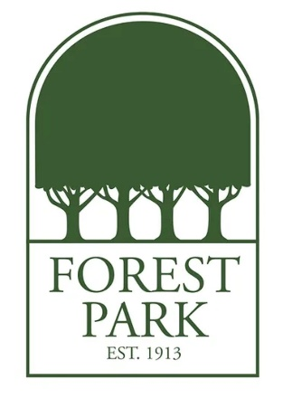
Ms. Rouse's Favorite Things:
Birthday: February 5
Drink of Choice: Coke
Place to Eat: Texas Roadhouse
Initials: V.J.R.
Sweet Treat/Snack: Chocolate Covered Cashews and Almonds, Milk Chocolate and Caramel Ghirardelli
Colors: Purple, Royal Blue
Favorite Place to Shop/Gift Cards: Amazon
Hobbies & Interests: Movies, Shopping, Jewelry Making
Lunch Order: Chick-fil-A (#1 with a Coke)

