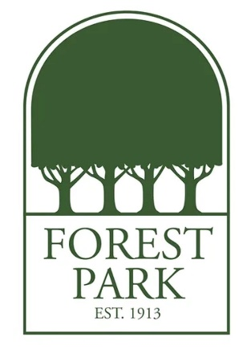
Ms. Wallace's Favorite Things:
Birthday: July 30
Drink of Choice: Sparkling water
Place to Eat: The Fold
Initials: Y.A.W.
Sweet Treat/Snack: Chocolate Covered Nuts
Colors: Red
Favorite Place to Shop/Gift Cards: Anthropology
Hobbies & Interests: Reading and Zumba
Lunch Order: Unsweetened Tea

