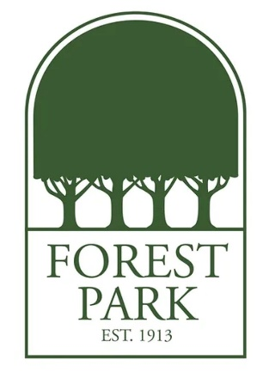
Mr. Finney's Favorite Things:
Birthday: June 9
Drink of Choice: Coke Zero
Place to Eat: Casa Manana
Initials: J.D.F.
Sweet Treat/Snack: Mixed Nuts
Colors: Orange
Favorite Place to Shop/Gift Cards: Target
Hobbies & Interests: Reading, Travel
Lunch Order: Sonic (#1 with fries and an Arnold Palmer to drink)

