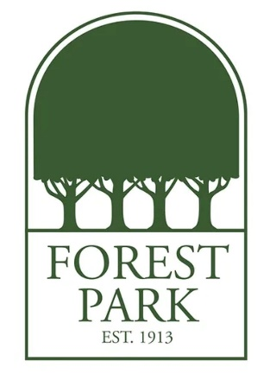
Ms. Graves's Favorite Things:
Birthday: July 22
Drink of Choice: Sonic Unsweetened Tea or Black Coffee
Place to Eat: Boulevard Bread
Monogram Initials: I.M.G.
Sweet Treat/Snack: Dark Chocolate Covered Espresso Beans
Colors: Red
Favorite Place to Shop/Gift Cards: Target
Hobbies & Interests: Reading, camping, and kayaking
Lunch Order: Chick-fil-A (nuggets, fries and Chick-Fil-A sauce)

