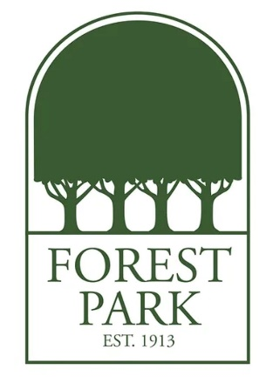
Mr. Farr's Favorite Things:
Birthday: September 28
Drink of Choice: Coke or Sweet Tea
Place to Eat: U.S. Pizza
Initials: K.P.F.
Sweet Treat/Snack: Doritos
Colors: Green
Favorite Place to Shop/Gift Cards: Academy Sports or Amazon
Hobbies & Interests: Track & Field, Coaching
Lunch Order: Chick-fil-A Chicken Tenders

