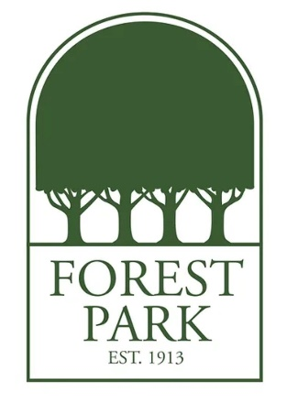
Mr. Farr's Favorite Things:
Birthday: September 28

